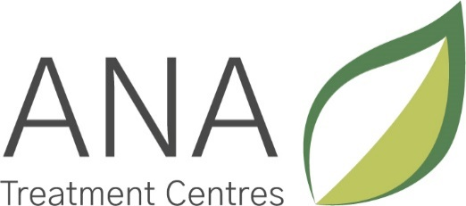

Policies and Procedures
Complaints: Policy, Procedure and Guidelines
Policy Statement
We hope that the services ANA provide are of the quality you expect. We would like to hear what you think and to learn from both your good and bad experiences of ANA services.
ANA strives to satisfy the needs of our clients and stakeholders, but does realise there are occasions when someone would like to make a complaint about the service they have received. A complaint is an expression of dissatisfaction, however it is made, about the standard of service, actions or lack of action by ANA or its staff, affecting an individual client or other stakeholder of the organisation. ANA hopes that when a concern arises, it can be dealt with informally, by talking through the situation and resolving the issue as it happens. If you still feel you would like to make a formal complaint, the following document provides the appropriate details.
1. How to Make a Complaint
There are various ways to make a complaint, to suit what is appropriate for the individual and the situation:
- Through any member of ANA staff
- By telephoning the ANA office (023 9237 3433)
- In writing, and either given to a member of staff or posted
- Through another individual who is supporting you, or representing you (e.g. friend, family member, care manager etc.)
Your complaint will be treated in the strictest confidence, and only those involved in the investigation or resolving the situation will know who made the complaint.
We ask that if you make a complaint, that you please provide us with as much information as possible regarding the situation. The following are examples of important information to include:
- What service, policy, person or aspects of ANA are you are complaining about.
- If appropriate, the date, time and location where an incident may have taken place and who may have been affected.
- Any expectations you may have had of ANA services, as a result of information we provided or what staff may have said.
- Your name, address and contact details so that we can respond to your complaint.
- Anything else which you think would help to make your point and help us to investigate your concerns.
2. What can you expect if you make a complaint?
- You will be treated fairly, with dignity and respect and your concerns and comments will be taken seriously. You should not be afraid to complain.
- Should your complaint raise any concerns about the protection of vulnerable adults this may be dealt with under other procedures (e.g. Safeguarding Adults Policy) but you will be informed.
- We will attempt to resolve your complaint as swiftly and fully as possible.
- You will be given help to find someone to support you with your complaint if you need it.
- If your complaint regards an external agency to ANA, we will not neglect our duty of care to you
- You will be informed of your rights throughout the process.
- Any promises made will be kept.
- Your views will be used for ANA services to learn from and develop positively

3. Complaints Procedure
This section details how your complaint will be handled by ANA. In the first instance, your complaint will be dealt with by the staff member who receives your complaint. You will be reminded of this policy and the process involved in addressing your complaint. The member of staff dealing with your complaint will refer it to the appropriate person for investigation and inform you of whom this person is.
We will try to resolve your complaint informally, satisfactorily and as quickly as possible as soon as we receive it. But if the matter cannot be resolved immediately, we will write to you to acknowledge receipt of your complaint within 5 working days of it being lodged, and then provide a fuller written response.
We will send you a written response to your complaint within 15 working days of it being lodged. This could be our final response to your complaint or a progress report of how we are investigating your concerns. Where we have provided you with a progress report, we will continue to provide you with further progress reports, until your complaint has been dealt with.
If we have not acknowledged your complaint within five days of receiving it or have not provided you with a full written response within 15 days, then we will write to explain the reasons why and to give you a date by which time we expect to be able to give you a full or final response.
3.1 Appealing a Decision
When we have provided you with a full response we will ask you whether you are satisfied with the way in which your complaint has been handled. If you are not satisfied, a Senior Manager will contact you and explain how your complaint will be handled at this second stage and will formally investigate your complaint. We will send you a full written response within 20 working days. Any extension to this period will be with your agreement and we will continue to provide you with further progress reports until your complaint has been dealt with.
When we have provided you with a full response at this stage, we will once again ask whether you are satisfied with the way in which you complaint has been handled. If you are not satisfied, your complaint will be referred to one of the Directors, who has overall responsibility for administering ANA’s complaints procedure and for arranging further investigations where necessary.
3.2 Putting Things Rights
If it is appropriate, ANA will provide a formal written apology to the people concerned. Where a complaint has been investigated and has led to the identification of potential improvements to services or how they are delivered, we will always give careful consideration to any recommendations.
4. Support in Making a Complaint
You can ask for support, if you feel you need it when making a complaint. This can be a friend, relative or any kind of advisor you feel comfortable with. This person can speak or write to ANA on your behalf. If you need help in finding someone to support you through this process, ANA will arrange for you to receive support via your funder. If you are a private client, ANA will help you seek support from the voluntary sector.

5. Anonymous Complaints
We will investigate anonymous complaints in the same way outlined above and seek to put things right if the complaint is found to be justified.
However, if an anonymous complaint involves alleged misconduct by a member of staff which, if proven, would be grounds for disciplinary action, then the appropriate staff member responsible for disciplinary matters will investigate the complaint.
6. For when you are not satisfied with the outcome
If, following the completion of the internal complaints procedure, you still do not feel satisfied, you can contact one of the bodies below for more support, advice and assistance in how to proceed:
Care Quality Commission (CQC)
National Customer Service Centre:
Telephone: 03000 616161
Fax: 03000 616171
Address:
CQC National Customer Service Centre
Citygate
Gallowgate
Newcastle upon Tyne
NE1 4PA
Local Government Ombudsman
Help making a complaint
Telephone: 0300 061 0614
Address (for letters): PO Box 4771, Coventry CV4 0EH
Text ‘Call back’: 0762 480 3014

Prepared by: |  | The Management Team
Issue/review date: |  | July 2015, July 2016, July 2017, July 2018, July 19, July 20, July 21, July 22
Review date: |  | July 2023
Status: |  | Approved

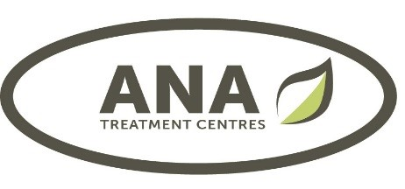

Complaints Form

Date Time By Whom

Details of Complaint

(continue on separate sheets if necessary)

Signed

Response (within 5 days)

Investigated by Date

Outcome

